Your University at your side
Coming to the end of your studies
Counsellors at the University of Wolverhampton:
- provide free and confidential individual counselling
- offer non-judgemental support and understanding
- are professionally trained
- are experienced in dealing with a wide range of problems

Counselling can:
- help you to develop your strengths
- offer you the chance to focus on and understand your difficulties
- enable you to make positive decisions and changes
- help you to develop the skills and resources to cope
- help prevent small problems from becoming bigger.

Get in touch
You can make an appointment to see a counsellor by filling out the Contact Us form at www.wlv.ac.uk/SSW, alternatively, you can come along to one of our drop-in services. For more information go to the web address above and click on the Mental Health and Wellbeing option. From here you will find a wealth of useful information and self-help tools as well as our Drop-ins and Group activities.

Coming to the end of your studies
A guide to help you with the next stage

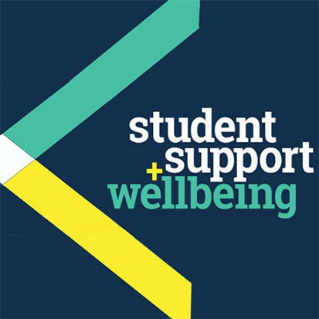

University Counselling Service

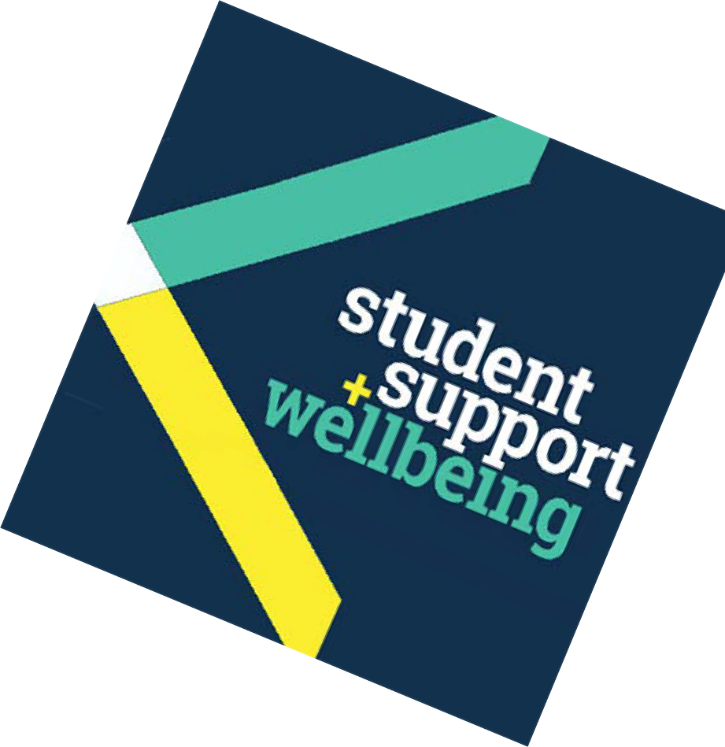

Introduction
Whether you are graduating as a mature student or finishing study in your early twenties, leaving university is a significant moment in life.
Completing your studies introduces a period of change and adjustment.
As with other major life changes which are considered positive, such as settling down with someone, giving birth, getting a new job, we generally expect to feel only happy and fulfilled. Most people, however, experience negative feelings too – a sense of loss for what has gone before and also a need to adjust to what is to come. This is true of finishing your university course, too.

The end of the semester
This is usually a time when there’s a lot going on
- you may have been working extremely hard to finish coursework and sit exams.
You may be anxious about whether you have done yourself justice. Or you may feel either disappointed or delighted with your grades.
You may have had to move out of your accommodation and find somewhere new to live. Or you may be returning to live at home, having been independent for a few years. Or yet again, you may need to spend more time at home with the children.
Pressure may be mounting on you to decide what to do next with your life.
The cumulative stress of all of the above may leave you feeling run down and/or overwhelmed.

Losses v gains
It is useful to think in terms of both what you stand to lose, and also what you may gain by moving onto the next stage in your life.

What you may lose by ending university:
- Friends.
- Routine/structure.
- Sense of belonging somewhere.
- A goal to head towards.
- Role or identity as a ‘student’.
- Relationship with the University environment.

What you may gain by ending university:
- A qualification.
- A career and graduate income.
- New friends.
- Independence.
- A new role or identity as a ‘graduate’.
- Relationship with a new working environment.
- Your weekends!

The unknown
Leaving university can throw up many options, and you are faced with making some key decisions. You are entering the unknown and need to shape your post-university life in a way that seems right to you.
It is hard in this period of decision-making not to be influenced by those close to you who may have their own expectations for your future. So whether you choose to pursue a career goal, earn money in a temporary job, or take time out to rest or do something different, it is important to think about your priorities.

How can you help yourself through the change?
- Think about the change before it happens so you feel prepared for it, rather than caught out by it.
- If you feel stressed and/or overwhelmed, look after yourself by taking time to relax.
- Acknowledge and accept feelings of loss and worry as equally normal as positive feelings.
- Talking to friends and family may help you work through the period of adjustment in preparation for your new life.
- Help is available to support you in your next career step (remember that Careers, Enterprise and the Workplace within the University is open to graduates too).

- It takes time to settle down somewhere new, and if you are returning home to spend more time with the family, it may be necessary to renegotiate your role.
- Academic staff in your Faculty and staff in your Student Office and at the Students’ Union are available for consultation if you are worried about your results.
- Mark the end of university somehow. Make it satisfying for yourself, eg. say goodbye to friends and staff who have had a positive impact on you, and/or make arrangements to stay in contact with others. Don’t forget to congratulate yourself on successfully reaching the end of your studies!
- If you feel particularly anxious towards the end of the semester, or if, after your course has finished, you feel very low and isolated and can’t come
to terms with moving on, you can still use the University Counselling Service for a while to get confidential support.

You might like to look at: www.prospects.ac.uk

People you might want to contact:
- Careers, Enterprise & The Workplace on tel: 01902 321 414 (The Workplace tel: 01902 323 400) or visit: www.wlv.ac.uk/careers
- The Student’s Union and Advice Centre, for financial advice and guidance with academic concerns on tel: 01902 322 038

Other useful websites:
The Royal College of Psychiatrists
www.rcpsych.ac.uk/healthadvice/atozindex.aspx
Advice from Mind:
www.mind.org.uk/information-support/mental-health-a-z/
Useful leaflets:
www.ntw.nhs.uk/pic/selfhelp/
Health A-Z at:
www.nhs.uk
Free meditation exercises: http://franticworld.com/free-meditations- from-mindfulness/

