Other useful websites
Managing stress
MIND: the mental health charity

mind.org.uk/information
The Royal College of Psychiatrists

rcpsych.ac.uk/mentalhealthinformation.aspx
NHS (Northumberland, Tyne & Wear)
Follow the links to a range of self-help guides

ntw.nhs.uk/pic

Your University at your side
Mental Health and Wellbeing at the University of Wolverhampton:
- provide free and confidential individual counselling
- offer non-judgemental support and understanding
- are professionally trained
- are experienced in dealing with a wide range of problems
Managing stress
Feeling stressed? A guide to help you identify and address your individual stressors.

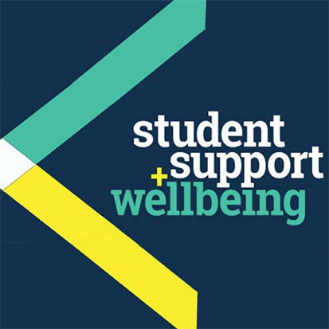
Counselling can:
- help you to develop your strengths
- offer you the chance to focus on and understand your difficulties
- enable you to make positive decisions and changes
- help you to develop the skills and resources to cope
- help prevent small problems from becoming bigge.r

Get in touch
You can make an appointment to see a counsellor by filling out the Contact Us form at www.wlv.ac.uk/SSW, alternatively, you can come along to one of our drop-in services. For more information go to the web address above and click on the Mental Health and Wellbeing option. From here you will find a wealth of useful information and self-help tools as well as our Drop-ins and Group activities.

University Mental Health & Wellbeing

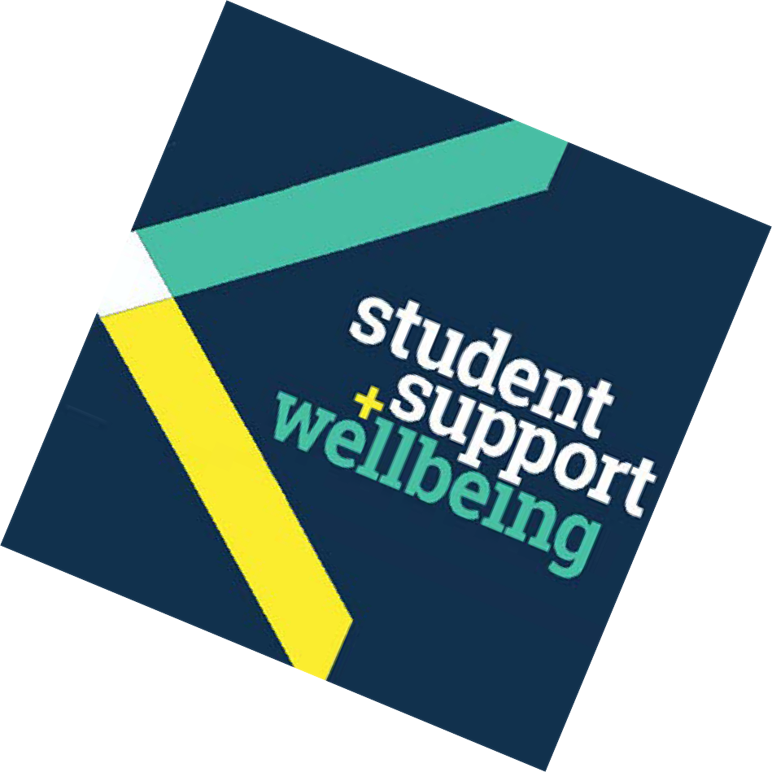What is stress?
We all talk about stress .. too much on our minds.. too much to do.. too many unreasonable demands… situations over which we have no control..

“Stress is a psychological and physical response of the body that occurs whenever we must adapt to
changing conditions, whether those conditions are real or perceived”.

The symptoms of stress occur when we feel that the demands placed upon us exceed our ability to cope. Stress, however, is a normal part of life and occurs in all kinds of situations, both negative and positive, for example work deadlines; illness; financial difficulties; relationship difficulties; changes in our lifestyle and environment; falling in love; going on holiday; graduating; getting a new job; etc..

People react to stress in different ways and will respond differently at different times in their lives. As our responses are often instinctive, it is important to recognise when we are feeling stressed, what are our individual symptoms
of stress, and what it is that is specifically causing us our stress (known as our individual ‘stressors’). And, as a degree of stress is useful in certain situations, the goal is not to eliminate stress but to learn how to manage it and use it positively.

What are some of the signs and symptoms of stress?
Stress can affect your feelings, thoughts, behaviour, and
body. Below are some of the symptoms that may be experienced:

Feelings: anxiety, hopelessness, fear, moodiness and irritability
Behaviours: grinding your teeth, increased smoking/ drinking, changes in eating patterns, being accident prone Body: headaches, increased heartbeat, perspiration/ sweaty palms, sleeping problems
Thoughts: racing thoughts, poor concentration, forgetfulness, low self-esteem

It may seem obvious, but situations which are often experienced as stressful include those during which you are or think you are, being judged, such as, examinations, interviews, meetings, presentations, and social interactions, etc..

Tips for reducing stress
There are various things you can do to reduce, or even eliminate, stresses in your life. Here are a few suggestions that you may find helpful.

- Try to learn more about the symptoms of your own stress.

- Work out what your ‘stressors’ are – what are the specific things which cause you to feel stressed, as these can vary from person to person.

- Learn to manage your time better – and make sure to take some time out each day to devote to yourself.

- Challenge your negative thinking – be aware when you use words such as ‘must’, ‘should’ and ‘ought’. Try to replace them with more moderate terms such as ‘might’, ‘could’ and ‘may’.

- Express yourself! Try to be more open about your feelings rather than bottling things up.

- Set realistic goals – remember to do your best, rather than trying to be perfect.

- Avoid alcohol, drugs and excessive amounts of caffeine – all can make your stress and problems worse in the longer term.

- Talk problems over with trustworthy friends or family members.

- Try eating more healthily and maintaining a regular sleeping pattern – a healthy routine helps your body in better dealing with stress.

- Take up something you enjoy. Try some physical exercise or a new hobby.

- Learn to relax properly, and learn some breathing techniques (see next page) or try some mindfulness exercises.

- Try not to think of ‘complete relief’ as the only solution.

Remember, with time and practice, you can master the skill of looking after yourself, and manage stressful situations more effectively.

What to do in a stressful situation
One of the simplest and most effective ways of reducing the symptoms of stress quickly is to alter your breathing.

You can benefit from changing your breathing pattern from one of rapid, shallow breathing to one of slower, deeper breaths.
- Breathe in through your nose deeply – hold for 3 seconds.
- Imagine you are breathing in positive energy.
- Breath out slowly through your mouth.
- Focus on the ‘out’ breath.
- Make the ‘out’ breath longer than the ‘in’ breath.
- As you breathe out, let all the tensions and worries flow out of your body.
- In your head, repeat a word that brings calm and peace as you breathe in. You will feel noticeably calmer after several minutes of deep, relaxed breathing.
You might like to attend one of our workshops on this and related subjects. Visit our website for details.

You might like to read:
Palmer, S. & A. Puri, A. (2006) Coping with Stress at University: A Survival Guide. London: Sage
Davis, M. Eshelman E. R & McKay M. (2008) The Relaxation & Stress Reduction Workbook (6th edition). California: New Harbinger

Other people you might want to contact
- Your doctor
- NHS 111, calls are free from landlines and mobiles, tel:

111
- The Samaritans for 24-hour confidential support – tel: 01902 426 422 or 08457 90 90 90 or visit: samaritans.org.uk
Some of the things students have said about the University Mental Health & Wellbeing Service:
“Counselling made issues more manageable.”
“Counselling has helped me to put my life into perspective and sort out my problems.”

