Modern Slavery & Human
Trafficking Statement
Year End 2022-2023

1. Introduction
2. Organisational Structure
3. Use of Recruitment/Agency Workers
4. Our Core Values
5. Speak Up Policy
6. Safeguarding Procedures
7. Due Diligence Process for Modern Slavery & Human Trafficking
8. Our Supply Chains
9. Compliance
10. Training
11. Update and Future Developments

- Introduction from the Board of Governors
Modern slavery is a crime and a violation of fundamental human rights. It takes various forms, such as slavery, servitude, forced and compulsory labour and human trafficking, all of which have in common the deprivation of a person's liberty by another in order to exploit them for personal or commercial gain.
We are committed to improving our practices to ensure there is transparency in our own business and in our approach to tackling modern slavery throughout our supply chains, consistent with our disclosure obligations under the Modern Slavery Act 2015 (as amended). We expect the same high standards from all of our contractors, suppliers and other business partners.
This statement is made pursuant to section 54(1) of the Modern Slavery Act 2015 (as amended) and constitutes our group’s slavery and human trafficking statement for the financial year ending 31 July 2023.

- Organisational Structure
We are a Higher Education provider based in the United Kingdom, with campuses in Wolverhampton, Walsall and Telford, Learning Centre in Burton and Cyber Quarter in Hereford. We have c. 20,000 students within the UK and abroad and approximately 1,956 UK based staff. Our annual turnover in the financial year ending 31st July 2023 was £176.2m

The University of Wolverhampton Higher Education Corporation within its group structure has a number of established subsidiary companies which are either wholly or jointly owned. Further details on the group structure can be found here https://www.wlv.ac.uk/about-us/governance/legal-information/publications-scheme/who-we-are-and-what-we-do/

- Use of Recruitment/Agency Workers
The University uses specified, reputable employment agencies to source labour, using a rigorous procurement process, which is committed to assisting in the eradication of unethical business practices including bribery, fraud, corruption and human rights abuses, such as Modern Slavery and child labour, before it accepts any workers from that agency.

The University has recently appointed Adecco to manage all Agency Workers, this ensures a centrally controlled service monitoring, not only Moderns Slavery concerns but also, payment methods and general management information.

- Our Core Values
These values guide the decisions we make and how we engage with communities, our partners, staff and students and apprentice learners both locally and globally. Various University procedures, including the Dignity at Work and Study policy and the Staff Expectations Document make it clear to employees and workers the actions and behaviours expected of them when representing the University.
https://www.wlv.ac.uk/staff/media/departments/human-resources/policies-and-procedures/Dignity-at-Work-and-Study-Policy.pdf

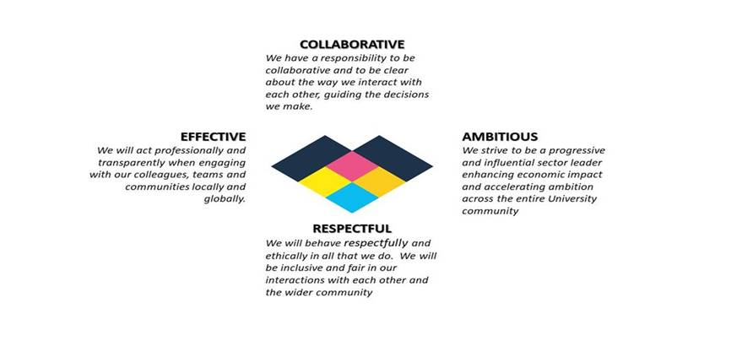
- Speak Up Policy
Our Speak Up Policy (https://www.wlv.ac.uk/about-us/corporate-information/wlv-policies/speak-up-policy/) encourages all of our workers to report any concerns related to the direct activities at the University. This covers any circumstances that may give rise to an enhanced risk of slavery or human trafficking. This is also relevant where anyone may be concerned about the activities of contractors.

Whilst Students and apprentice learners are not employees of the University and not covered by the provisions of the Public Interest Disclosure Act and the related policy, the University remains committed to ensuring the highest professional standards and urges students and apprentice learners with concerns to raise these through the Student Complaints Process and Procedure. https://www.wlv.ac.uk/about-us/governance/legal-information/complaints/

- Safeguarding Procedures
Our duties as staff members (within the University community) are regularly communicated to all staff and extend to safeguarding concern for our students, apprentice learners, each other, guests and visitors. This includes protecting the rights of adults to live in safety, free from abuse or neglect; and working together to prevent and stop the risks and experience of adult abuse and neglect - including exploitation.

We have a clear process in place for reporting any concerns with regard to Safeguarding and Prevent related matters, and are committed to working with the relevant authorities or agencies where necessary, in consultation with the University Safeguarding Group , which is chaired by the Chief Operating Officer and University Secretary as the University Designated Safeguarding Lead. Any Safeguarding concerns should be directed to The University Safeguarding provision via (safeguarding@wlv.ac.uk) in the first instance. https://www.wlv.ac.uk/about-us/corporate-information/safeguarding/

- Due Diligence Process for Modern Slavery and Human Trafficking
As part of the University’s due diligence processes, Contract management activities incorporate a review of the contractor compliance and the controls they have in place to assess their own supply chains.
We maintain processes to:
- Identify and assess potential risk areas in our supply chains.
- Mitigate the risk of slavery and human trafficking occurring in our supply chains.
- Monitor potential risk areas in our supply chains via modern slavery compliance statements for formal Tenders.

The University will not knowingly support or deal with any business involved in slavery or human trafficking, we take a zero tolerance approach to slavery and human trafficking. In the event that any Contractor/Supplier is suspected to be operating in this manner a review will be held and the organisation potentially removed from any formal contracts.

- Our Supply Chains
Our supply chains include goods, services and works from a wide range of organisations across a number of categories. We use reputable contractors and expect them to have adequate monitoring procedures and certifications in place e.g. for clothing, we request all Tenderers to comply with Social Accountability International Standard SA8000 and request evidence on their ethical sourcing activities.

All Tenderers complete the standard Cabinet Office Supplier Questionnaire. The successful Tenderer is requested to provide copies of, or links to, their Statements and Polices where relevant.
- Compliance
We continue to review compliance of this statement including through use of the existing university transparency and safeguarding policies which could involve members of the following areas:

- Legal
- Human Resources
- Finance including Procurement
- External Engagement
- Global Opportunities Office
- Directorate of Students & Education
In addition, there is a University Safeguarding Group which comprises of officers from some of the areas listed above but not solely which also reviews the Modern Slavery Statement. This group meets 3 times per year.

- Training
To ensure a high level of understanding of the risks of modern slavery and human trafficking in our supply chains and our business, relevant Procurement staff are Chartered Institute of Procurement and Supply (CIPS) qualified or working towards the qualification and therefore follow the CIPS Code of Conduct. This is detailed in our Procurement Strategy and Policy documentation. We have also structured our online training provision to be available to any personnel who may be working on behalf of the University, thus covering temporary personnel and critical contractors. Modern slavery is covered within the University’s Safeguarding training module.

- Update and Future Developments

Following a review of the effectiveness of the steps we have taken to ensure there is no slavery or human trafficking in our supply chains in 2022/23, we committed to a number of actions. Below is an update on those actions:
- The Supplier Code of Conduct is available on our Procurement webpages and will be referenced in the General Statements section when conducting a formal Tender; a link will also be added to the Purchase Order to cover spend activity that has not involved Procurement. (https://www.wlv.ac.uk/media/departments/finance/documents/UoW-Supplier-Code-of-Conduct---FINAL-July-2019.pdf)

- We have developed and implemented a Modern Slavery Policy which is accessible on our Governance webpages. https://www.wlv.ac.uk/about-us/corporate-information/wlv-policies/modern-slavery-and-human-trafficking-policy-/

- The Transparency Policy has been updated in the last year which is now the Speak Up Policy. In order to continue to ensure compliance in this area, we take the following steps to combat slavery and human trafficking:
- We keep our Speak Up Policy under review to ensure that it provides adequate processes for reporting incidents related to modern slavery and human trafficking.
- We continue to monitor compliance of contractors via Tender submissions and ongoing Contract Management.
- We continue to assess any ongoing specific training needs for staff undertaking further training as required in respect of the Modern Slavery Act.
- As part of our Governance Effectiveness review, to enhance our decision making, we seek to build an ethical framework which will complement existing policies and procedures to embed the Universities ethical values and principals in all our activities.
https://www.wlv.ac.uk/about-us/corporate-information/wlv-policies/speak-up-policy/ https://www.wlv.ac.uk/about-us/corporate-information/wlv-policies/modern-slavery-and-human-trafficking-policy-/

Endorsed by Angela Spence, Chair of the Board of Governors, University of Wolverhampton
January 2024
.

