Before first use or after storage:
Fill the kettle with fresh water. Boil the water. Pour away the boiled water. Repeat this two or three times.The kettle is now ready for use.
DESCALING
In hard water areas furring or lime deposits forming on the concealed element may result in increased boiling time and affect the kettle operation. If this deposit is not removed it can cause damage to the kettle.The scale can be removed by using an appropriate descaler available from Tesco and hardware stores or chemists. Follow the instructions with the descaler. After descaling boil the kettle several times with fresh water before use. Do not descale too often as this may shorten the life of the element.Thoroughly clean the exterior of your kettle to remove any traces of descaler; failure to do somay damage it.
Do not immerse any part of this appliance in water or other liquid when cleaning the appliance and never use any abrasive cleaners or scourers.
STORAGE
Excess cord can be stowed by feeding the cord into the storage cavity in the base of the unit. When not in use the kettle should be stored on its base out of the reach of children and pets.
WARRANTY
Your TESCO appliance is warranted for 12 months from the date of purchase. If a fault develops during this period, please return the unit to your nearest Tesco store together with the original receipt as proof of purchase.This warranty in no way affects your consumer rights.
Voltage Rating: 220 - 240V AC, 50Hz Power Consumption: 2550-3000W Water Capacity 1.5 litres
NetWeight 940g
THIS APPLIANCE MUST BE EARTHED

THIS APPLIANCE MUST BE ATTENDED AT ALL TIMES WHEN OPERATIONAL

SAFETY AND OTHER FEATURES

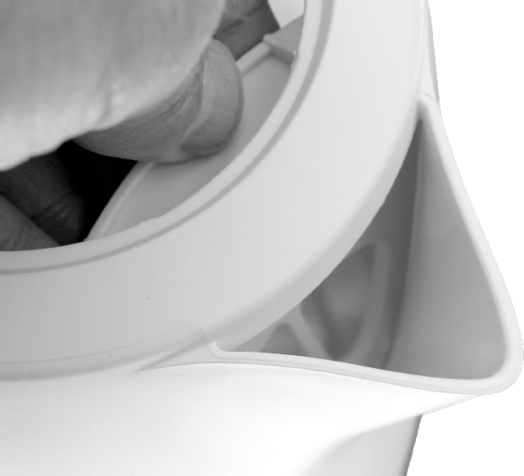
Removable Scale Filter
The filter traps scale. If you fill the kettle via the spout, the effectiveness of this filter will be reduced.
A: To remove the filter: Allow the kettle to cool and open the lid. Gently press the catch at the top of the filter between finger and thumb and pull the filter back slightly. Lift the filter out.
B: To replace the filter: Locate the bottom of the filter in the slot at the base of the spout. Press the catch down and ease the filter into place. Do not use force.

Boil Switch with Auto Cut-Out
When boiling water, do NOT hold the switch down or steam will be ejected from the lid and you may damage the automatic switch off mechanism. Always ensure that the ON/OFF switch is clear of obstructions, readily operable and is not prevented from switching off.

Boil Dry Protection
Your kettle is fitted with a safety device which switches it off if the appliance is operated with insufficient water. If this occurs, the kettle should be switched off at the mains and allowed to cool thoroughly before refilling with cold water.The safety device will then reset.

Overheating Shut -Off
In the event of gross overheating, your kettle will automatically shut down to prevent further damage. Should this occur, take it to a qualified service person for examination and repair.

CLEANING
Switch off at the mains and remove the plug from the socket outlet before cleaning. The appliance can be wiped clean with a damp cloth.
Remove the filter. Brush the filter in running water to remove any adhered scale. After cleaning replace the filter.

Tesco Stores Ltd,
Welwyn Garden City AL7 1GA, U.K.

UK: Waste electrical products should not be disposed of with household waste. Separate disposal facilities exist, for your nearest facilities. See www.recycle-more.co.uk or in-store for details.
ROI: Produced after 13th August 2005. Waste electrical products should not be disposed of with household waste. Please recycle where facilities exist. Check with your Local Authority or retailer for recycling advice.

Electric Kettle

JKRWP13 JKRBP13

USER GUIDE

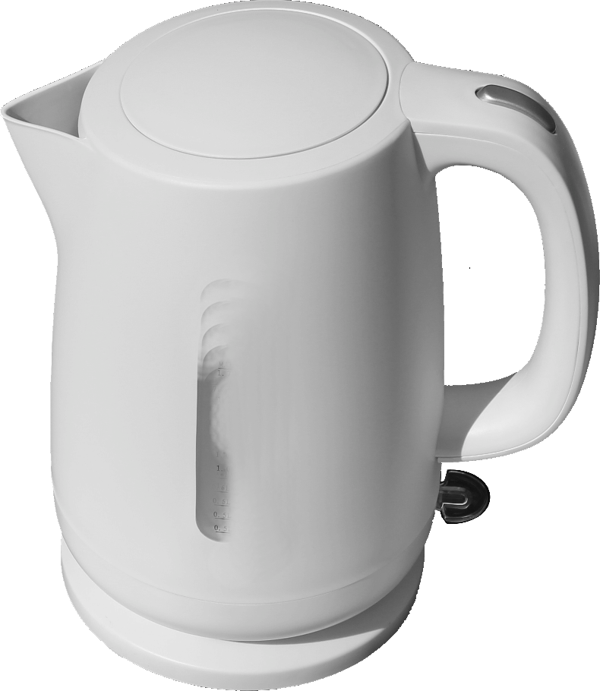

SAFETY GUIDE USING YOUR KETTLE

Please follow all the safety precautions listed below for safety and to reduce the risk of injury or electrical shock.
 Do not touch the body of the kettle when it is hot. Always hold the appliance by the handle when using it.
 Always ensure the lid is closed when in use. Failure to close the lid will prevent the thermostat from switching off and cause the kettle to boil dry.
 Keep the appliance well away from hot surfaces, and objects that can be damaged by heat.
 Ensure there is adequate room to operate the kettle and that steam can escape safely. Never use the kettle under a cupboard or shelf where the steam may damage the surface.
 Avoid contact with the steam from the spout when the water is boiling or just after it has switched off.
 Be careful when opening the lid for re-filling when the kettle is hot.
 Ensure that the kettle cannot fall into water.
 Do not fill or pour water from the kettle while it is on the base.
 Disconnect the kettle at the mains supply before filling or emptying the jug, before cleaning any of its components, and when it is not in use.
 Do not immerse the connecting cord in water or other liquids.
 Do not allow liquids to come into contact with the terminal pins of the kettle, its base or the

CAUTIONS
 Do not place the power base unit on a metal tray or metal surface when plugged into any power source.
 This appliance is for indoor domestic use only. Do not use it outdoors.
 This kettle jug and power base form an integral appliance. Do not use other kettle jugs with this power base, or this kettle jug with other bases.
 The switch on this appliance must be readily operable at all times. Do not hinder its operation by incorrect placement or by placing obstacles that may restrict its free movement.

ABOUT YOUR KETTLE

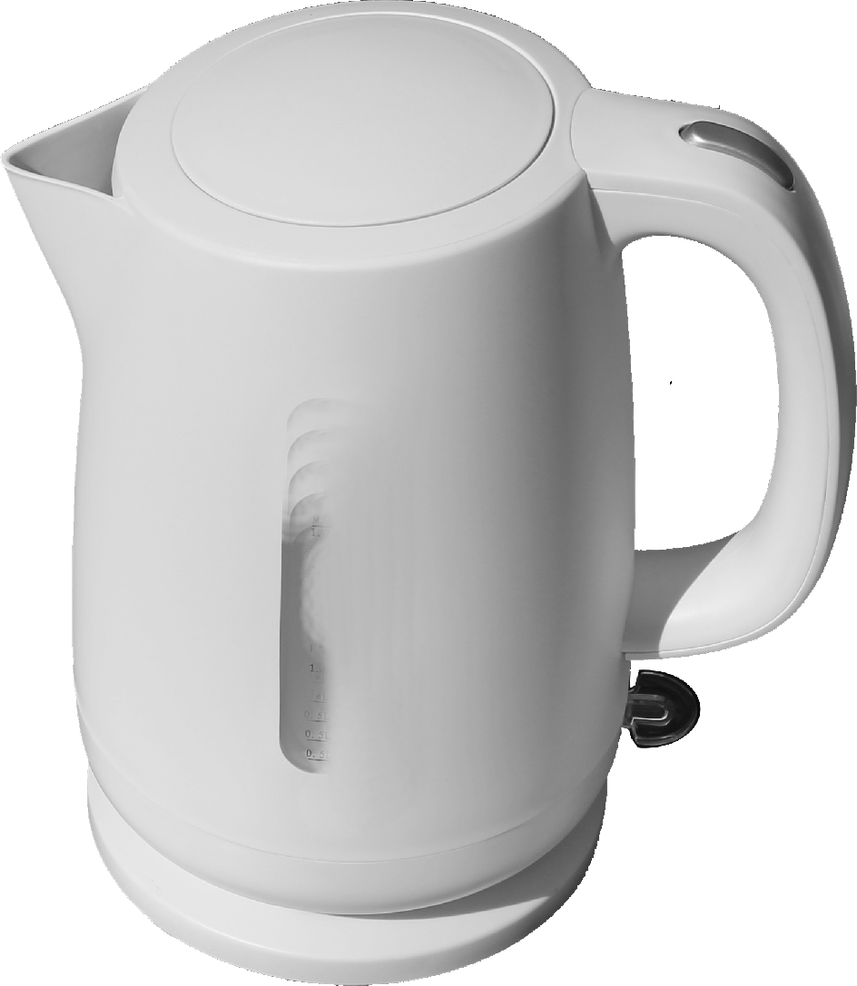
d
b e
PRELIMINARIES
Unpack your kettle and any accessories carefully. Retain the packaging so that you can transport the appliance safely. If you dispose of it please do so with regard to any recycling regulations in your area.
Before using your kettle: Check that the voltage marked on the rating plate under the kettle or the base matches your mains voltage. Please read all the instructions in this User Guide with particular reference to the safety notes.

OPERATION
Separate the kettle from the base. Ensure that the mains socket is switched off at the wall. Lead the power cord out through the recess in the base. Place the kettle base on a stable level surface and connect the power cord to the wall socket. Excess cord may be safely stowed by feeding it carefully into the stowage compartment in the base. Ensure the powercable exits the cut out slot otherwise the kettle basewill not be stable.
Pour away previously boiled water.
Press the lid release button to lift up the lid.
Fill the kettle with fresh water. The MIN and MAX marks are located on the water scale . The water level must always cover the MIN (0.5 litres) mark . Do NOT fill the kettle above the MAX mark (1.5 litres) , or boiling water may be ejected. Close the lid
Place the filled kettle correctly on the power base.
Boiling the Kettle

connecting cord.
 Do not let the connecting cord overhang the edge of the work surface or allow it to touch hot surfaces or sources of heat or flame.
 If any part of this appliance is damaged or malfunctions in any way, or the connecting cord or mains plug is broken do not continue to use it. Seek expert assistance.
 "This appliance can be used by children aged from 8 years and above and persons with reduced physical sensory or mental capabilities or lack of experience and knowledge if they have been given supervision or instruction concerning use of the appliance in a safe way and understand the hazards involved. Children shall not play with the appliance. Cleaning and user maintenance shall not be made by children unless they are older than 8 and supervised .
 Keep the appliance and its cord out of reach fo children less than 8 years.
1: Spout c
2: Water Filter (In Spout)
3: Kettle Lid
4: Lid Release
5: Handle
6: ON/OFF Switch
7: Kettle Base
8: Kettle Jug
9: IlluminatedWater Scale

j

Switch on the power at the wall socket.
The kettle ON/OFF switch is located below the handle. Press this down to the“I”position to switch the kettle on.The water scale will illuminate showing the kettle is operational.
When the water has reached the correct temperature, the kettle will switch off.
You can stop the boiling at any time by lifting the switch up to the“0" position. To re-boil, press the switch
f again. If the water is very hot, it may be necessary to wait until the switch resets.
Always ensure the lid is tightly fitted and never lift it while the kettle is boiling or you run the risk of scalding. If
g the lid is not correctly fitted while boiling, the automatic cut-out will not operate, you may boil the kettle dry and cause damage due to excessive steam emissions.
After boiling, switch off the appliance at the mains. The kettle may now be safely removed from its base and the boiled water poured out. Always take care to pour boiling water slowly and carefully without tipping the kettle
h too quickly. Never leave hot water in the kettle while it is unattended.
i After use, replace the kettle on its base.

